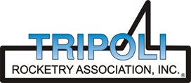
Tripoli Motor Testing Division
223 NC Highway 54 West
Chapel Hill, NC 27514
(919) 357 5681 (c)
April 17, 2024

Gary Rosenfield
RCS Rocket Motor Components, Inc.
2113 West 850 North Street
Cedar City, UT 84721

Dear Mr. Rosenfield,

The Aerotech L2775ST-PS reload kit was tested on March 30, 2024 and complies with NFPA 1125. The motor is certified for hobby rocketry use by the members of the Tripoli Rocketry Association and all approving organizations with reciprocal certifying agreements.

Motor Manufacturer RCS Rocket Motor Components, Inc.
Manufacturer’s Designation L2775ST-PS [for the 75/3840 hardware]
Propellant Super Thunder
TMT Nomenclature 3150 L2774

Diameter 2.966” 75.34 mm
Overall Length 21.977” 558.2 mm
Outside the MMT 1.60” 40.69 mm

Loaded Mass 7.67 lb 3479.1 g
Propellant Mass 3.126 lb* 1418 g*
Burnout Mass 4.30 lb 1950.5 g
* = data provided by manufacturer

Burn time 1.135 ± 0.017 sec

Total Impulse 708.13 ± 1.36 lbf.s 3149.9 ± 6.1 N.s

Max Impulse 695.90 ± 16.75 lbf 3095.6 ± 74.5 N

Average Impulse 622.91 ± 10.78 lbf 2773.5 ± 45.7 N

Number of Motors Tested 3

Nominal Measured
Delay Time Data n.a. n.a.

Casing Temp. [NFPA 1125 7.4.1] Passed

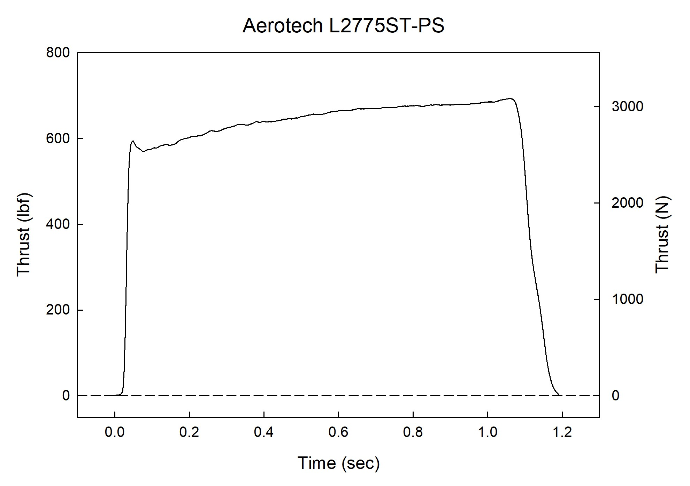

Sincerely,

Alan C. Whitmore
Chair, Tripoli Motor Testing

